The New Digital Yacht WL400:
High Power Long Range Wi-Fi For Boats
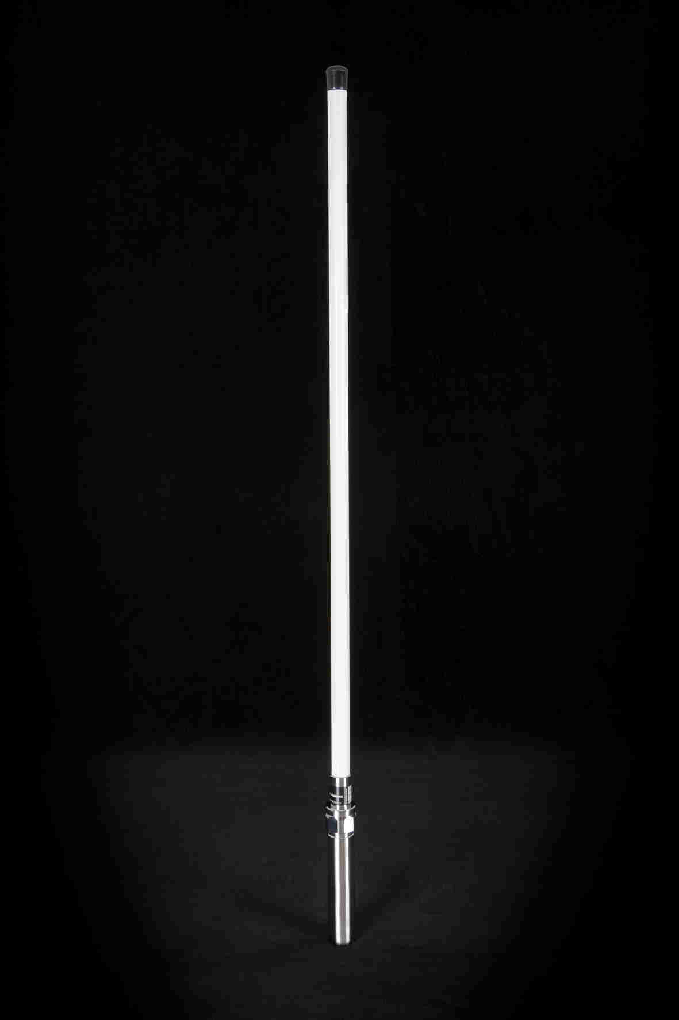
Digital Yacht have launched a new high power long range Wi-Fi access system called the WL400. It allows boat owners to connect to Wi-Fi hot spots so that their on board PCs or laptop can access the internet. With internet connectivity on board, you can download the latest weather or chart updates as well as catching up on a few emails when you’re missing work! Most harbours and ports have either free or subscription based services available and with the extended range that the WL400 offers, it is often possible to tap into hot spots available in local cafes, bars and restaurants.
The system comprises a rugged 1 metre antenna which connects to a PC via a standard plug and play USB interface. All the electronics and modem are encapsulated within the antenna for easy installation and there is no need for an external power supply. The system picks up power from the laptop or onboard PC.
Wi-Fi range depends on many local factors but Digital Yacht have seen ranges of 1 to 2 miles with this low cost system. In general, using an internal Wi-Fi adaptor typically found on a notebook, you will be lucky to find the signal at the end of the dock so if you plan to access the internet whilst on board then the WL400 could be the solution for you.
The WL400 is priced at £299.95 including VAT and comes complete with a deck mounting base. Further details are available at www.digitalyacht.co.uk
- ENDS -
For further information, please contact:
Digital Yacht Ltd., Digital House, Unit 10 City Business Park, Easton Road, Bristol, BS5 OSP, UK.
Telephone: +44 (0)1179 554474
Email: sales@digitalyacht.co.uk www.digitalyacht.co.uk

For further press information, please contact:
Tina Mansell at The Mansell Agency
Telephone: +44 (0)1202 701705. Mobile: +44 (0)7973 850012
Email: tina@themansellagency.com www.themansellagency.com

